
God’s vineyard
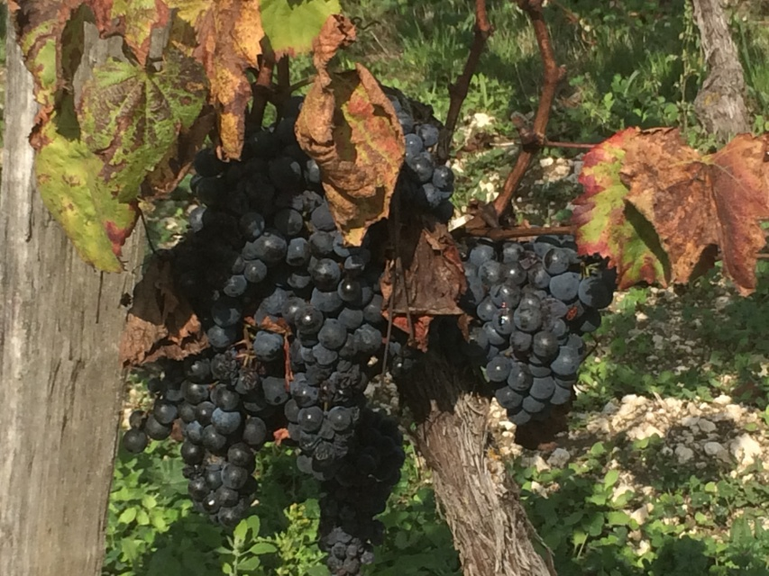
15th to 18th September 2026
A few retreat days at Colomba le Roc
In September there will be an opportunity to join us at Colomba le Roc for four retreat days around the theme of creating a vineyard, looking after the vines and sharing the fruit of the vine.
Tuesday 15th: “My beloved had a vineyard”: we will be focusing on gardening with God
Wednesday 16th: Part of the programme will be a visit to a local vineyard where we will learn about the work in the vineyard. The visit will include some wine tasting.
Thursday 17th: “I am the Vine” we will reflect on pruning and being connected to the Vine
Friday 18th: “To Life” a day around celebrating God’s love
Each day, except possibly Wednesday, will start at 10.30 am and finish at 16.30. It will include at least one guided meditation and/or a creative activity. There will be tea and coffee. Though soup or salad will be provided we suggest you bring your own lunch. The exact timing for the visit to the vineyard will be confirmed asap.
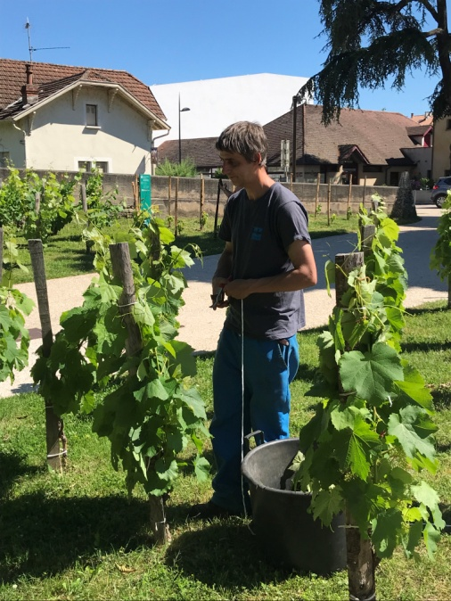
If you would like to join us for one or more days, for more information, or if you have any questions, please contact Joanne Evans-Boiten by email at: colomba.le.roc@gmail.com
Address: Colomba le Roc
510 chemin du Faurat, Belmontet
46800 Montcuq en Quercy Blanc

The retreat days are free though if you can afford it, a donation of around 20 Euros per day would be very welcome as it will help us continue to offer hospitality.
The visit to the vineyard is also free thanks to the generosity of Baptiste Bley and his family, but if you like the wine why not treat yourself, family or friends with a bottle or two?

